CSCE 5430, Fall 2021

Individual Assignment 3

**Due Date:** Friday, 10/8, 11:59pm

**Submission**: Canvas

# Weight: 5% of the total grade

**Assignment Description:**

1. (25 points) For each of these process models (waterfall, prototyping, phased (incremental or iterative), spiral, and agile), what are the benefits and drawbacks of using the model (one benefit and one drawback)?

| **Model** | **Benefits** | **Drawbacks** |
| --- | --- | --- |
| Waterfall | Simple and easy to explain to customers.  Easy to manage. | No way to handle changes to the product made before development finishes. |
| Prototyping | Allows repeated investigation of requirements.  Reduces risk and uncertainty in development. | Often poorly documented due to volume and variability in updates. |
| Phased Incremental and/or Iterative | Allows two systems to be functioning in parallel, one in development and one actually in use.  Allows training on the system to begin early. | Requires fully committed developers and customers.  Difficult to adopt new technologies into the system. |
| Spiral | Minimizes and controls risks.  Project development is well-planned and efficient. | Expensive, which is unsuitable for small projects.  Requires excessive documentation. |
| Agile | Focus on flexibility and producing code.  This is a simple process. | Requires expert project manager.  The necessary level of communication can be difficult to maintain. |

2. (10 points) Consider the process models learned in class. Which one gives you the most flexibility to change in reaction to changing requirements? Justify your answer.

Of the process models introduced, agile offers the most flexibility to *any* change. This model has less documentation and a less defined plan. This allows for larger freedom in implementation, and any changes made require less time and effort to negotiate and define. The iterative nature focusing on small deliverables also means that if any changes need to be made, it is easy to look back at the iterations and see when deliverables will start to be affected as well as what implementations won’t need change.

3. (35 points) Consider the following description of a chemical plant.

Temperature and pressure levels must be monitored for safety reasons. Sensors are installed to generate signals when either of these levels exceeds some predefined values. When one of the two signals is raised, a recovery action is automatically invoked (there are a “temperature action” and a “pressure action.”) If, after a while, the recovery action succeeds, the system is automatically reset to the “normal” state. Otherwise, the alarm signal must be raised and the plant must be shut off. The system must also be shut off if it is trying to recover from one kind of anomaly – temperature or pressure – and the other signal is raised. It is assumed that the two signals cannot occur simultaneously.

Use a **state transition diagram** to specify the operation of the chemical plant.

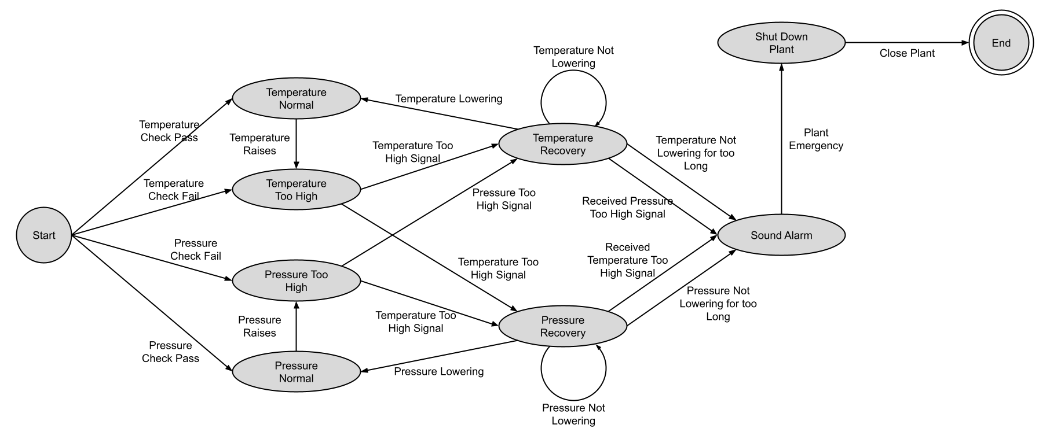

4. (15 points) Change the following non-functional requirements in a ***quantitative (measurable) way***.

1. *The system should terminate any operation immediately when the tank pressure is high.*The system should terminate all operations within five milliseconds once the tank pressure has read as 50 psi for one millisecond.
2. *The system should be user-friendly.*  
   The system should allow a user who has never used the system before to complete tasks within thirty extra seconds after ten minutes of use than a user who has worked with the system for a total of twenty hours.
3. *The system should respond to the user request very quickly*.  
     
   The system should respond to the user request within ten milliseconds.

**5.** (15 points)Requirements change over time due to several reasons, and requirements changes affect requirements engineering process in various ways. Why requirements change? List two reasons and briefly describe them. Also, identify two requirements from your project that are susceptible to change.

A major reason for change is that the requirements analysis process was done too fast or poorly, so the requirements are poorly defined or missing in the first place. This leads to them being changed later when they’ve been more thoroughly explored either by the developers or the client.

Another reason for change is that the client is uncertain or incorrect about what they want when they request the project. This leads to them changing the requirements later as they realize that what they first asked for wasn’t what they actually wanted.

One requirement for our project that has already changed is that we are switching the desktop interface from web-based to an installed program because that will be easier for us to develop.

Another requirement that is likely to change is the functionality to create recipe books. For time reasons we are liable to not allow the user to create their own recipe books and only have the public and created-by-current-user recipe books.

**Document formats:** Your documents may be in any of the following formats (1) MS Word (2) Adobe Acrobat (pdf).